Newsletter
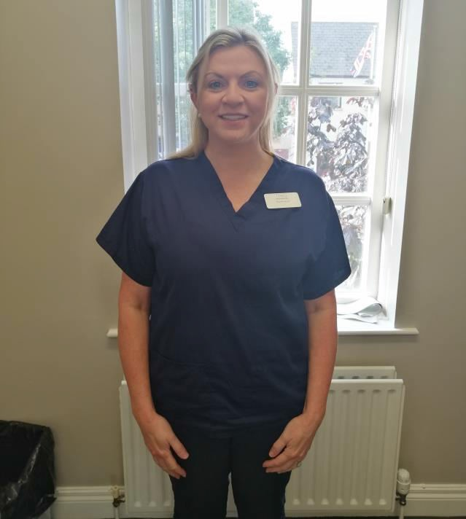BROUGHSHANE MEDICAL PRACTICE JULY 2019

Do you have a minor ailment?

- Acne Vulgaris
- Athletes foot
- Acute Diarrhoea
- Ear Wax
- Groin area infection
- Haemorrhoids
- Head Lice
- Mouth Ulcers
- Scabies
- Threadworms
- Oral Thrush
- Verrucae

Do you need to see a doctor?

No because you can get advice and appropriate treatment from your community pharmacist. The average pharmacist will see you in under 2 minutes with no appointment.

Why go to the pharmacists first?

- Pharmacists can offer advice and treatment for a wide range of minor ailments
- Treatments provided as part of the Minor Ailment Service are free of charge
- You will receive quick, expert advice without need to see your GP
- GP’s will be able spend more time focusing on patients with more complex medical needs

Can you go to any pharmacy?

Pharmacies offering the Minor Ailments Service will display an arrow and cross sign.

Our New Nurse
Tracy McSweeney, Practice Nurse

Tracy is from Cork and moved to Broughshane April 2018. She qualified from Cork University College with a diploma in Nursing studies.
She completed a Practice management training in 2005, and subsequently a Higher Diploma in Peri operative nursing in 2007. She moved to General Practice in 2007 and completed her diploma in family planning and has a certificate in diabetic management. Tracy is a registered smear taker and certified in giving travel vaccinations.
She was one of the directors for diabetic care (DIG) in UCC for 6 years supporting and auditing diabetes in primary care.
Special interest: Women’s health, STI screening, Cryo therapy, Minor surgery, Asthma/COPD Antenatal and Travel vaccination.

PLEASE TAKE A COPY OF THE NEWSLETTER WITH YOU

